The Ennerdale Lifting Stones
I began researching Stone Lifting in Cumbria at the start of 2024, convinced there must be a crossover of cultures and traditions with the Celtic people North of the border. There were only a very few books or websites available to learn about Stone Culture, but a fantastic half-finished book by the late great Peter Martin, was an incredible source of background. From this I got an understanding of where and how stones were lifted in Scotland and in other parts of the world. So I began my search.
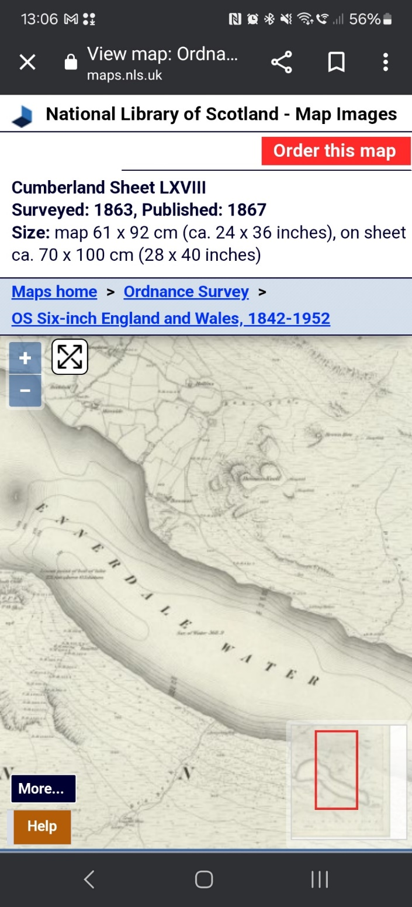
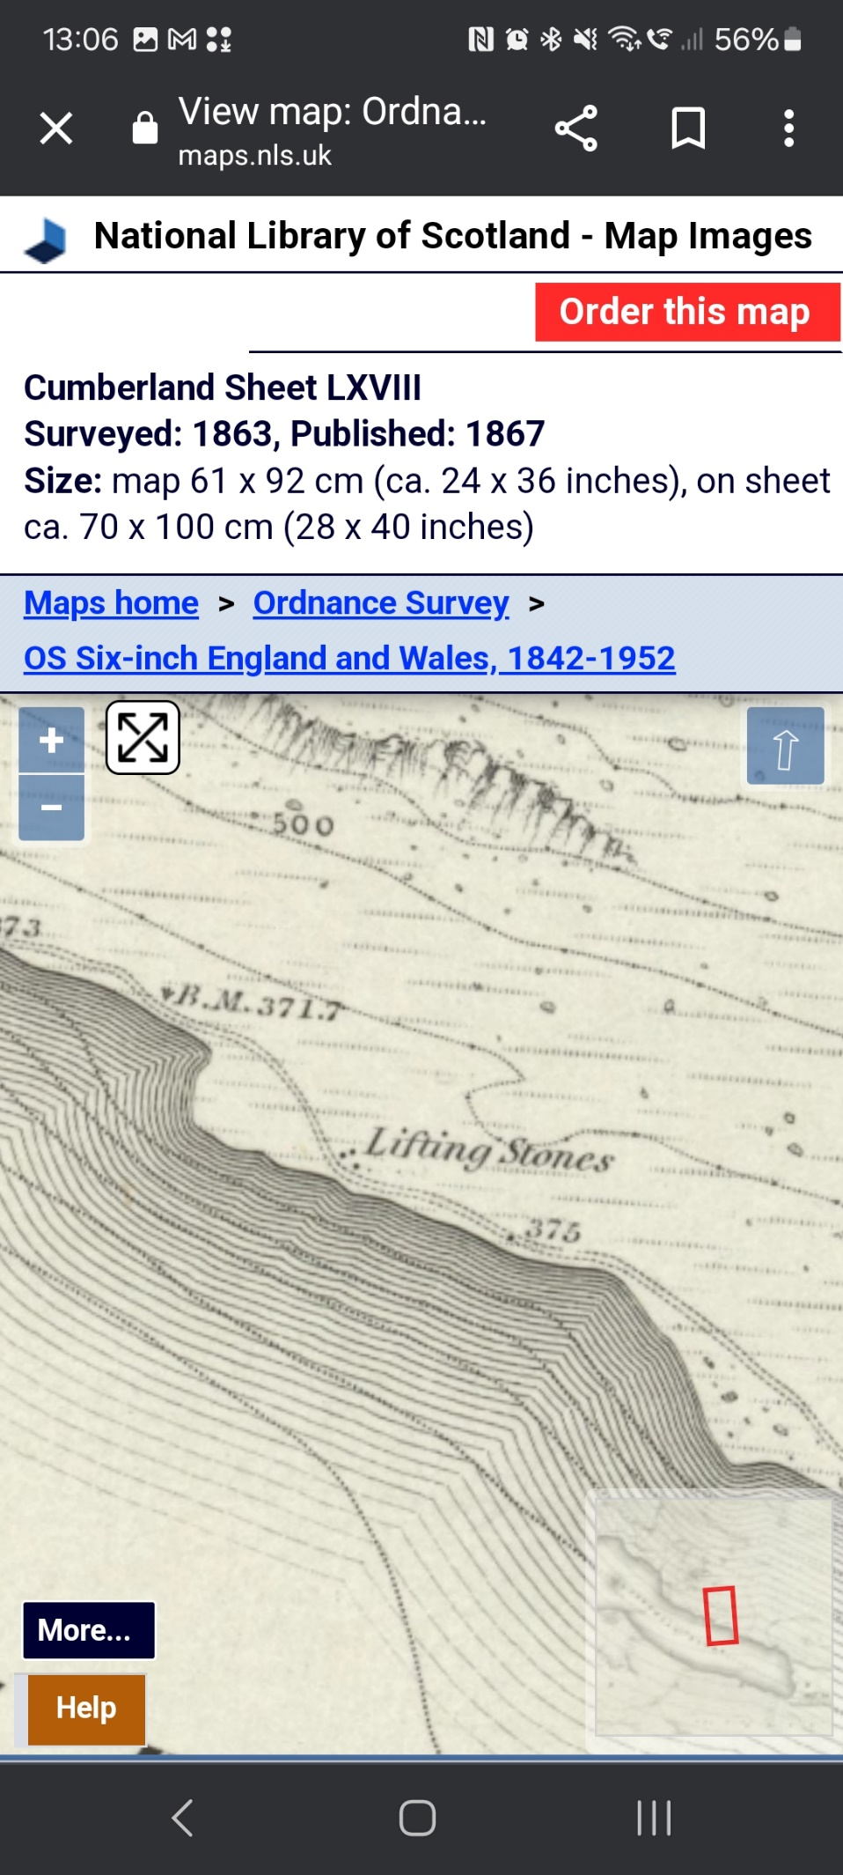

I first found reference to “Lifting Stones” listed on the old OS 1830’s County Maps, shown as 3 dots on the North Banks of Ennerdale Water, suggesting that there were three stones. Whilst the only other mention of them were in archaeological journals documenting the ancient medieval Bloomery (iron smelting works) found just a little further along the track at Smithy Beck. Yet all they would say was “the Bloomery is located close to the three lifting stones”. This to me suggested they were quite prominent, although not noted for any antiquarian value.
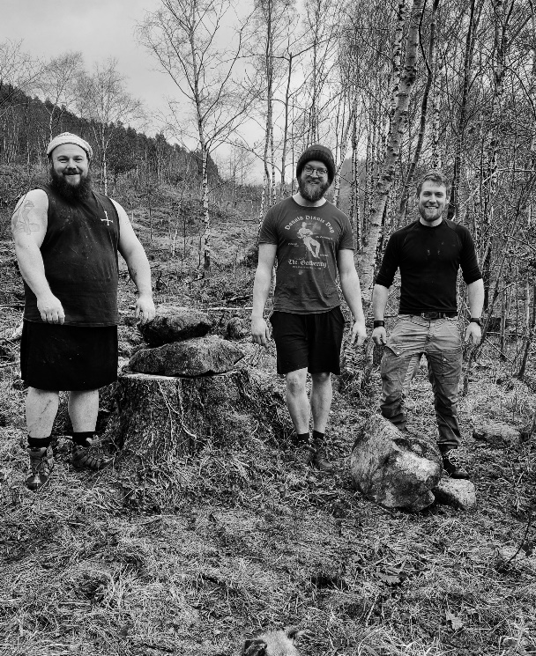
I got in touch with a couple of other Lifting Stone ‘hunters’ in Scotland and we made a visit in mid-February when the vegetation was still low and before I started lambing. Sadly we found no evidence of anything at the site. Although logging operations and a recently engineered track could be seen, suggesting the stones may have been lost to modern industrial works. Speaking to a local online, he believed that the stones were known about, as late as 1950 when the new forest road went in, and that he thought the stones had been moved because of this. The Forestry Commission unfortunately has very little documentation from this time at Ennerdale.
Before we left, as a nod to the old traditions, we decided to gather 3 stones from the mass that scattered across this hillside and placed them at the spot marked on the old maps. Of course we couldn’t leave without also giving them a lift too. Roughly they weigh 170kg, 100kg and 50kg.
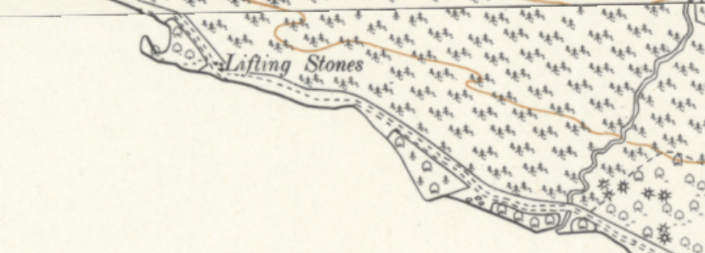
A few months later, I found myself once again pouring over old maps of Ennerdale, hoping to find some clue to a storage depot that the Forestry Commission might have left the stones at where they may have gone unnoticed. I came across three boulders marked on later maps from 1956 where none were shown previously, a mere 350m away from the marked location of the Lifting Stones. Could these newly marked stones be the original Lifting Stones? I thought it was certainly worth a visit to see if there was anything.

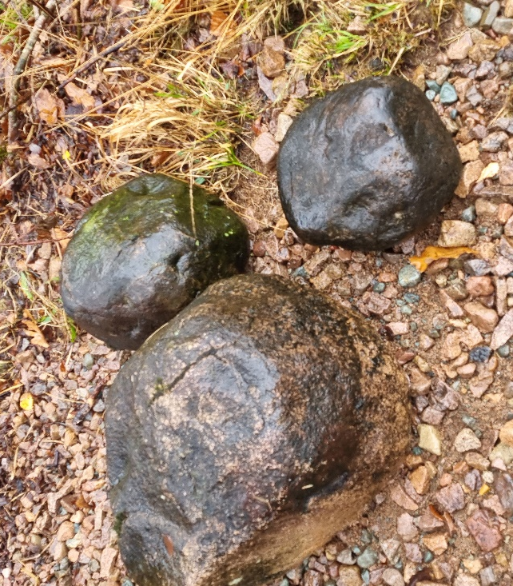
So almost 8 months after my initial visit, I found myself back out at Ennerdale. This time in the pouring rain. I followed the track down to the new location I had found on the later maps. Once again there was nothing to be found, at least not within the woods. But exploring the lakeside, just in the waterline spread across an are of maybe 20 meters I found 3 rounded stones of varying size. Which only stood out against the rest because of the smooth and roughly spherical shape compared to the blocky sharp stones of the area. Could they be one in the same? I doubted it. The largest was maybe 90kg, with the other two much smaller. All other Lifting Stones that I had read about were 100kg plus.
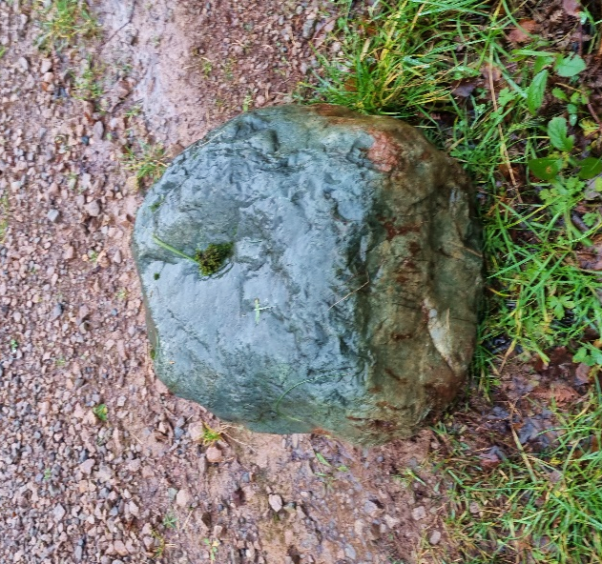
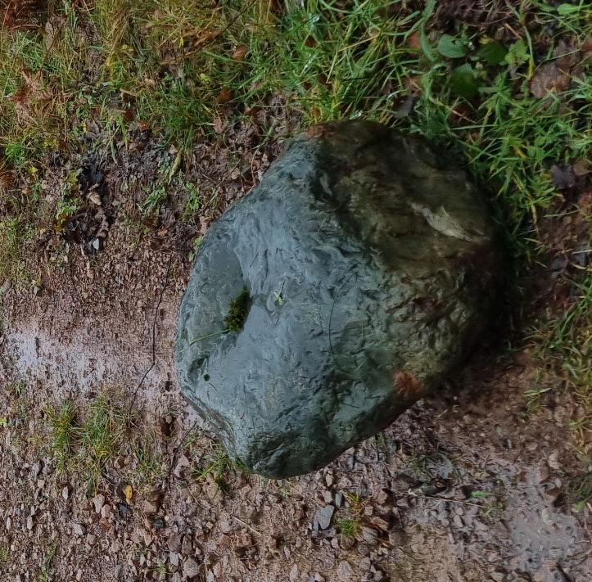
On my clamber back up the banking, I spotted a stone half buried in the vegetation that stood out. It was not the usual grey/brown of all the other rock types in the area. But a vibrant, deep blue colour. I’d not seen another stone like it in either this visit or the last. I pulled it out from its resting place and twisted it over, whilst not rounded it was glassy smooth where its blue hue was strongest; though its colour had faded where it sat beneath the surface. It was certainly not the same rock type as the local geology.
From reading about other known Lifting Stones, I was aware of several that were described as blue. The ‘Blue Stone of Old Hartley’ the ‘Bewkley Blue Stone’ and the ‘Blue Stones of Old Dailly’. They had served other purposes as either charter or moot stones, locations where the folks of the past had known to gather at. Could this distinctive blue stone have marked a gathering point on the approach to the Bloomery at Smithy Beck?
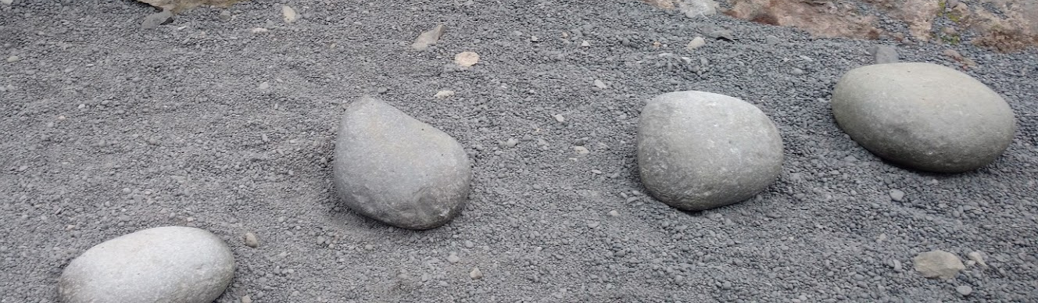
But what was the relevance to their being three? I spent another 10 minutes searching but could not find another 2 stones that matched this same blue stone. I knew of other lifting stones that came in groups, such as the Dritvik Stones in Iceland. Traditionally, they were used as a test for people to work on fishing boats in the 16th century. A captain would use them to find out how well qualified you were to work on the ships; by lifting the lightest you were considered strong enough to work. But by lifting your way up through the stones to the heaviest, you could secure a better position on the boat and greater pay.

They are named as such:

- Amlóði weakling — 23kg (50lbs)
- Hálfdrættingur half-carrier — 54kg (120lbs)
- Hálfsterkur half strong — 100kg (220lbs)
- Fullsterkur full strong — 154kg (340lbs)

Was it possible that these three stones, on the approach to the medieval bloomer were used as almost interview stones? To earn your right to work at Smithy Beck you would need to prove your strength. Of course this is all speculation, and we may never know their true purpose.

A few months later, my mind was once again ensnared by the Ennerdale Stones, surely there must be more known about them. I began looking for books on the area in general. I came across the book “Around and About Ennerdale”, written by Bob Orrell in1997. Within it I caught another break, as he writes:
“Just beyond the dub is the start of the Forestry Commission’s Smithy Beck Trail, and close to this spot there were three almost perfectly round boulders which local men used for weightlifting contests. The smaller one of the three was called the ‘Lady’s Stone’, the middle one the ‘Man’s Stone’ and the larger one, weighing over two hundredweight (101 kilos), was called the ‘Strongman’s Stone’. Unfortunately the stones were lost during road-widening operations in 1948.”
I was elated to find a real reference to them being used for trials of strength as I had imagined they were. Though a little disappointed by the description “almost perfectly round” which probably threw out the idea of the blue stone being one of the. Although the weight of the heaviest being supposedly 101kg, it made me rethink whether the original trio of stones I found could have been correct. Although it would have been a push to describe them as almost perfectly round.
The Lady’s Stone - The Man’s Stone - The Strongman’s Stone (est. 101kg)
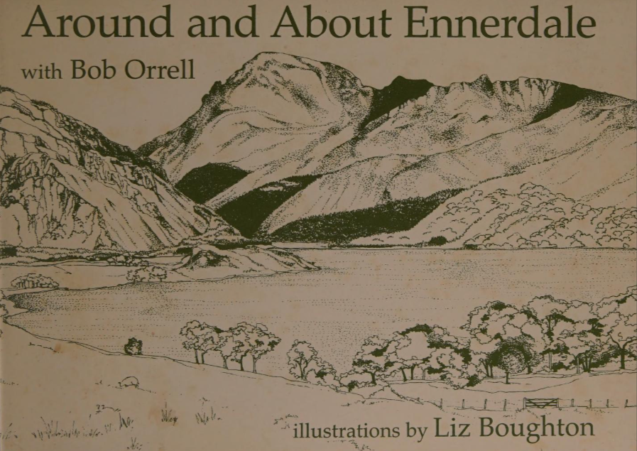
I reached out to Bob Orrell who was now 90 years old, he told me he had been passed the story by the late Joe Bird a local to the area, “who was a mine of information about Ennerdale, said that he remembered the stones and had plans to have them moved into the safety of the village. However, he reckons they disappeared and he blamed the Forestry Commission road building squad who had no interest in preserving items of historic interest”. So, I would have been surprised if the stones had remained hidden all this time if the likes of Joe Bird were on the lookout for them. The trio of stones I found on my wet and windy visit in November may well just be similarly rounded stones, whilst the original three lie buried beneath the forest road. But the unusual boulders marked on the map beyond 1950 do still make me curious.

Another stroke of luck befell my search. After posting on several groups online. A woman from nearby Cleator Moor got in touch with me to say she had a large stone in her garden and wondered if it might be connected. After speaking with her at length about her family’s history in the area, it turned out that her Great Grandfather once farmed at Ennerdale and her Grandfather worked at Gillerthwaite, planting trees for the Forestry Commission and would have driven wagons up and down the forest road, right past the stones in the early 1940’s
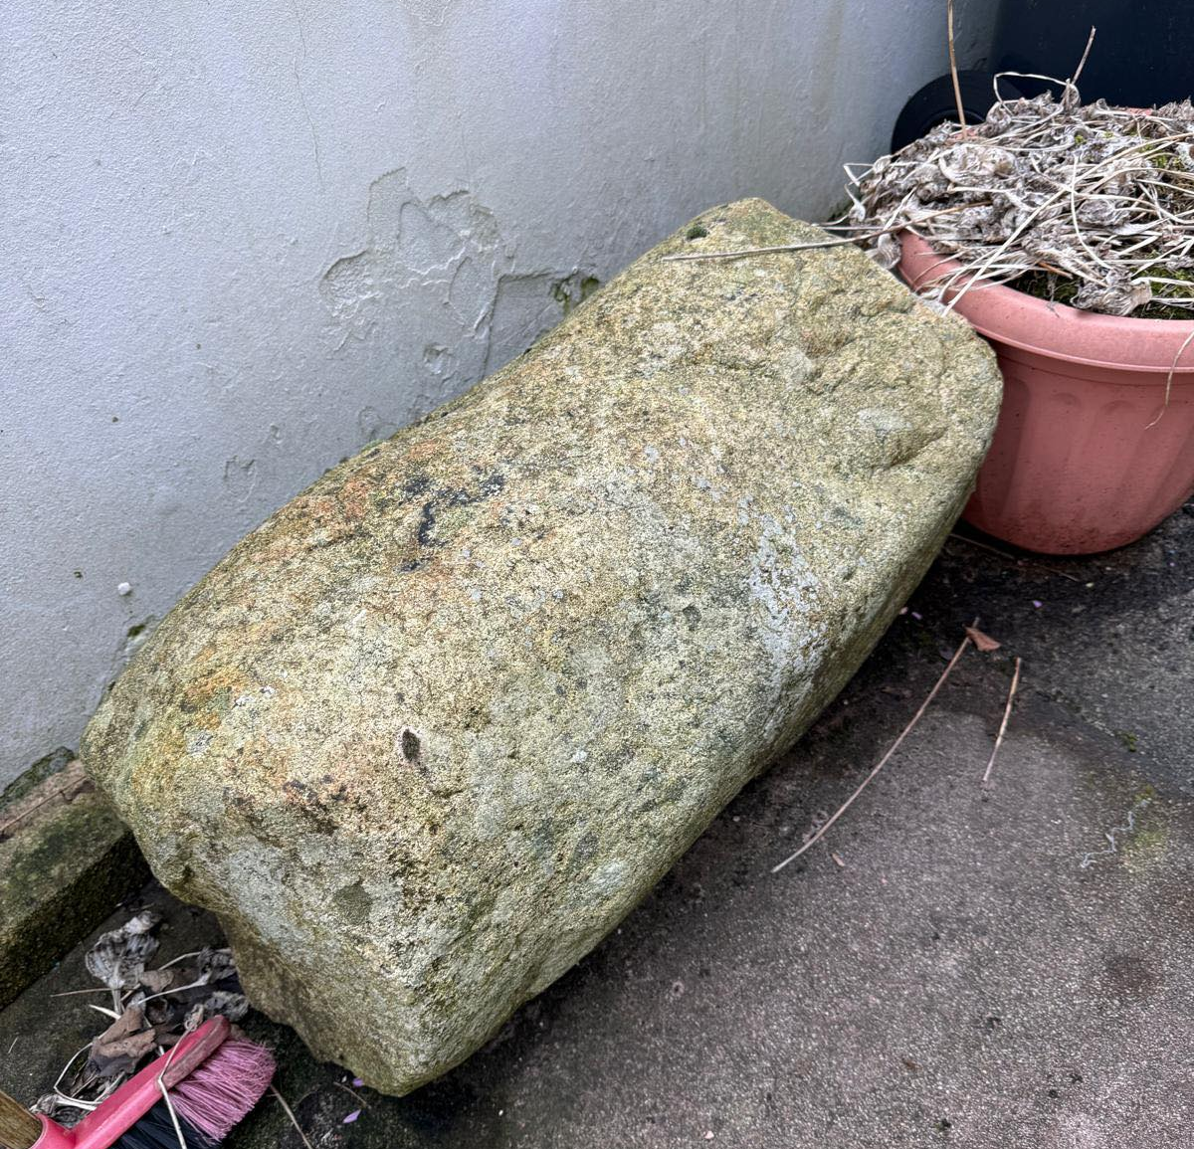
The stone had stood outside the end terrace of their home for as long as she could remember, where she and her sister would sit on it pretending it was a horse. Her Grandfather had moved to the end terrace house after leaving Gillerthwaite, though she didn’t know if the stone was already there or not. But sometime in the 1960’s or 70’s he moved the stone into the back garden. For what reason... we may never know.
Although far from being “almost perfectly round” as described in Bob Orrel’s book (although by the time he received a description of the Stones, they hadn’t been seen in almost 50 years). As can be seen from the above photo, it a large cylindrical shape. Could this be one of the lost Ennerdale Stones? Rescued by a local farmer’s lad who would have known of their existence and was driving past the very spot at the very time the track was being widened… who knows!?! But a man can dream!

The search continues…
Calum Stott
@sherlock_stones_

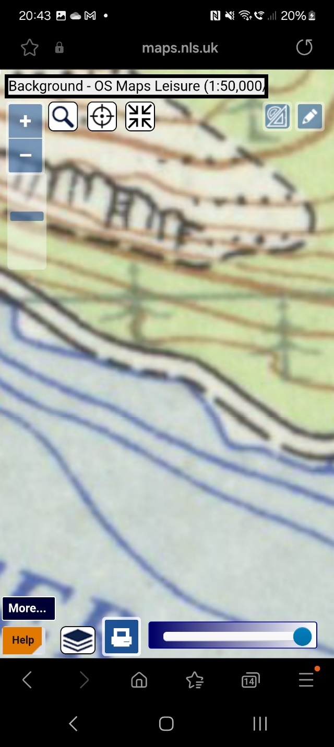
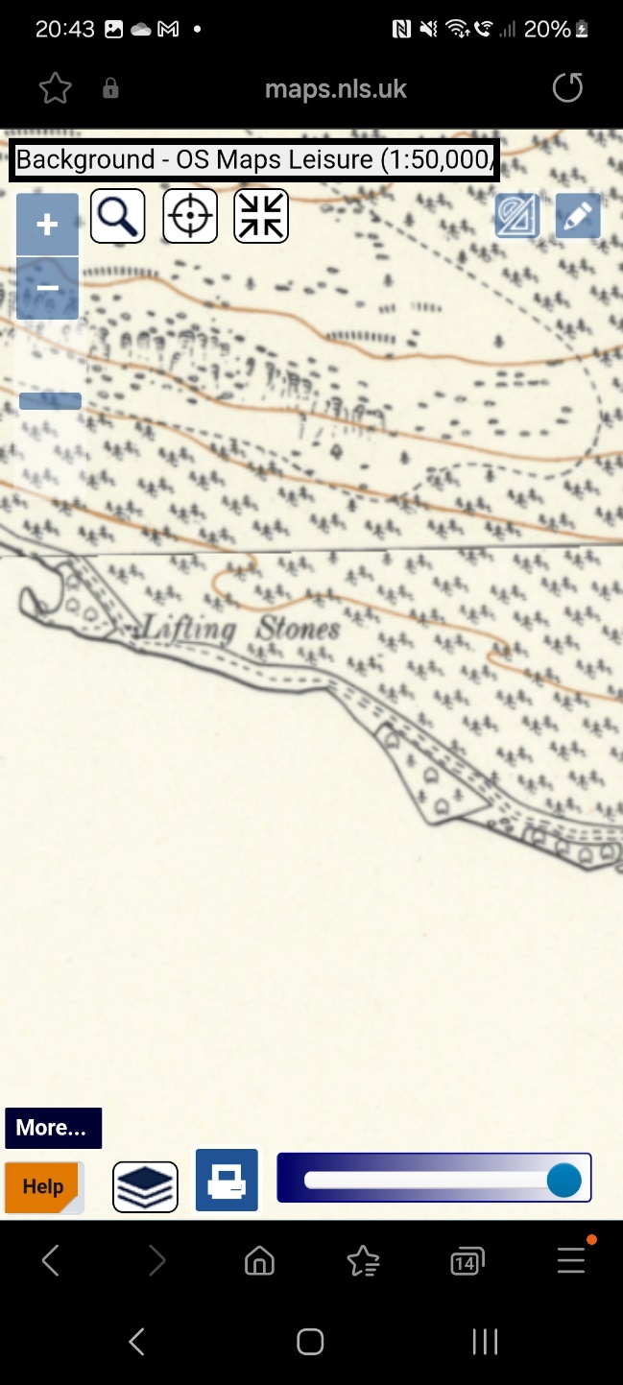
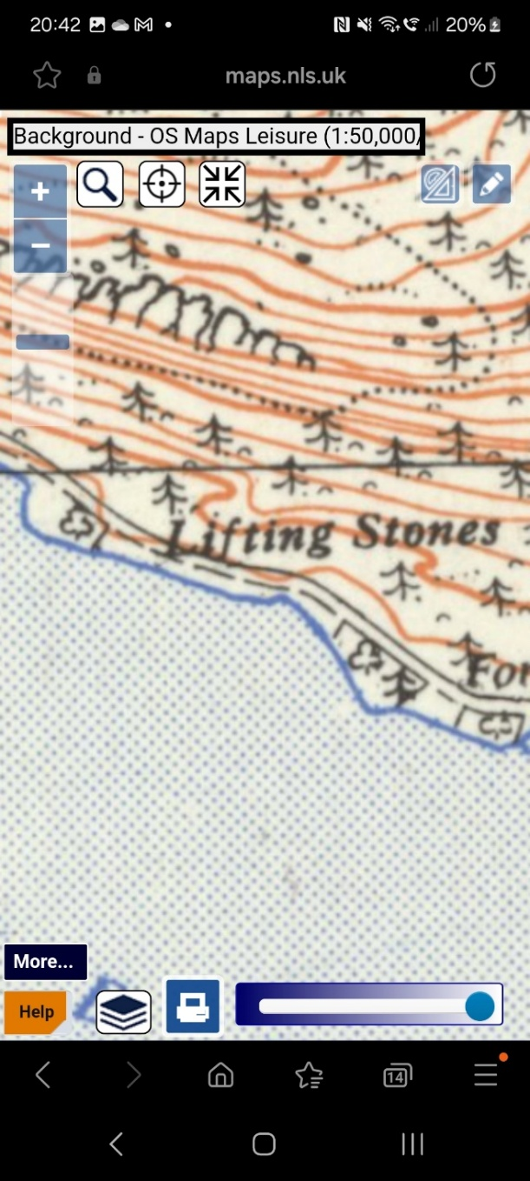
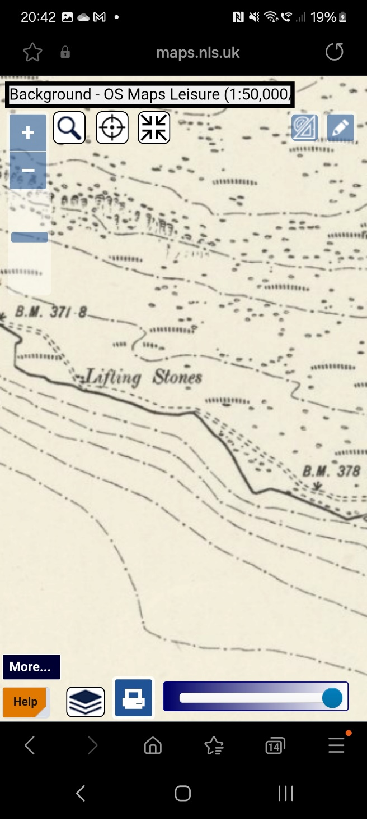
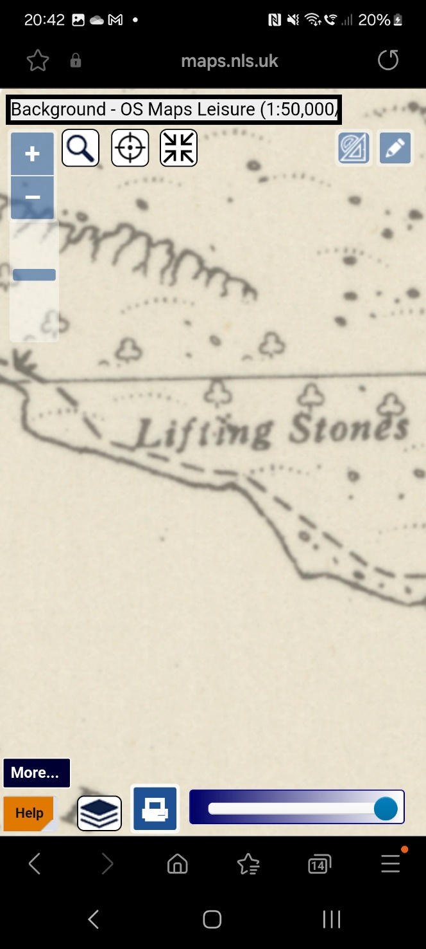
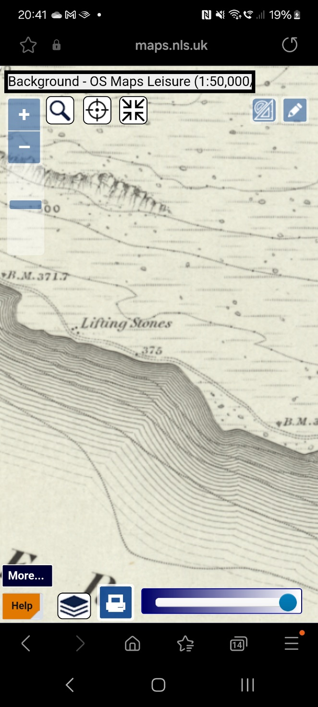
Appendix
Figure 4 – Revised 1946 – 1951 (Description, no stones marked on map)
Figure 3 - Revised 1930 - 1956 (Description & stones marked. Three new stones marked near enclosures, none marked previously)
Figure 6 - Revised 1951 – 1961 (No description or stones marked on map)
Figure 5 - Revised 1945 – 1965 (Description shown. No stones marked)
Figure 2 – Revised 1898 (Stones marked and described on map)
Figure 2 - Surveyed 1863 (Stones marked and described on map)

